**Project Title :** AI powered Nutrition Analyzer for Fitness Enthusiasts **Project Design Phase-I** – **Problem** **Solution Fit Template Team ID:** PNT2022TMID54073

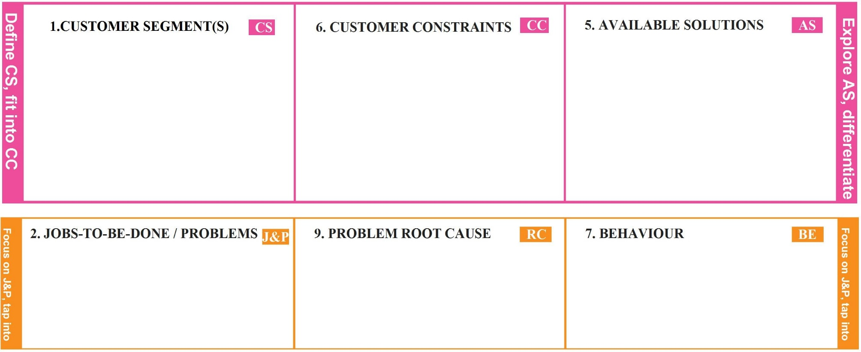

* Healthy Eaters
* Sports Persons
* Gym Trainers
* Internet Facility
* Spending Time

To detect the nutrition based on fruits like Sugar, Fibre, Protein, Calories etc. to make the users conscious about their foods.

* Incorrect Details
* Low quality image leads to wrong prediction of nutrients

●

●

Busy Schedule Laziness

* Consulting Doctors
* Maintaining their own diet

# TRIGGERS TR

**Identify TR &strong EM**

Through advertisements, neighbors or through social media

# EMOTIONS: BEFORE / AFTER

Before: Unhealthy, Confused After: Healthy, Confident

# 10. YOUR SOLUTION

To track the health care plan of an individual. To track the calories in the food by uploading images. To suggests food based on their health conditions.

# CHANNELS OF BEHAVIOUR

**ONLINE:**

**Identify TR &strong**

* + Through Social Media
  + Channel Advertisements

**OFFLINE:**

* + Suggests neighbors
  + Through pamplets

**EM**